OWASP TOP 10:

1.Broken Access Control:

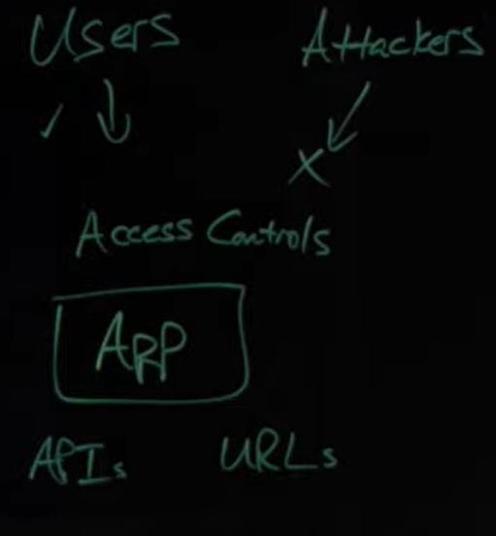

Prevention:

1.Denial by default.

2.Access control Mechanism and Monitoring.

3.Log Access Control failures.

4.Restriction of Access Outside the Org. premises.

**2.Cryptographic failures:**

1.Implemantation of weak/compromised algorithms.

2.Cryptographic focus on security of data in transit/rest.

Open-source: Google Tink, Libsodium.

Ex: Sensitive Data, Passwords, Credit Cards, Personal Data, Health Information.

Privacy laws: GDPR

Regulations: PCI Data Security Standards (PCI DSS)

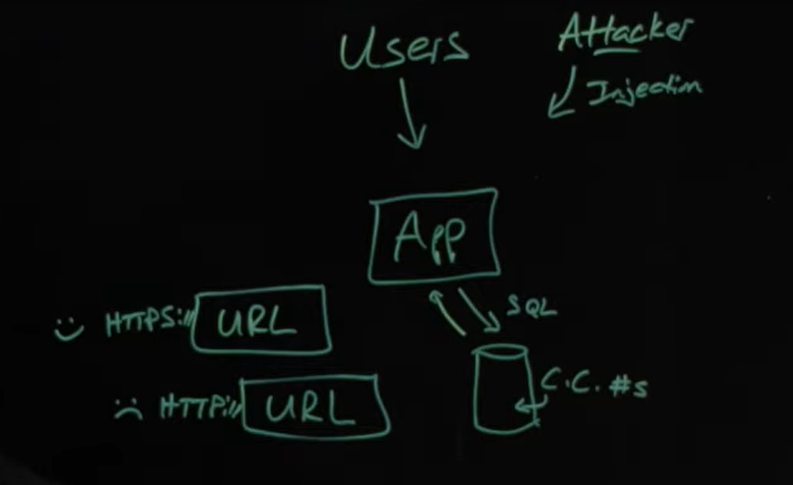

**3.Injection:**

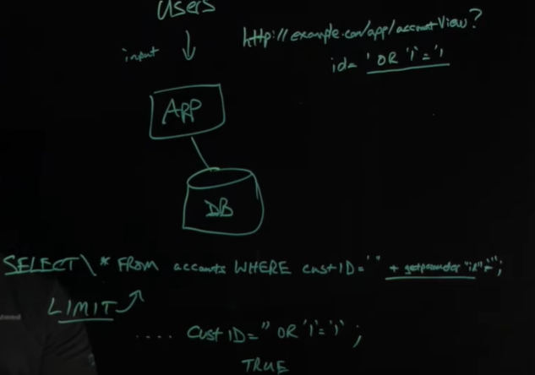

**4.Insecure Design:**

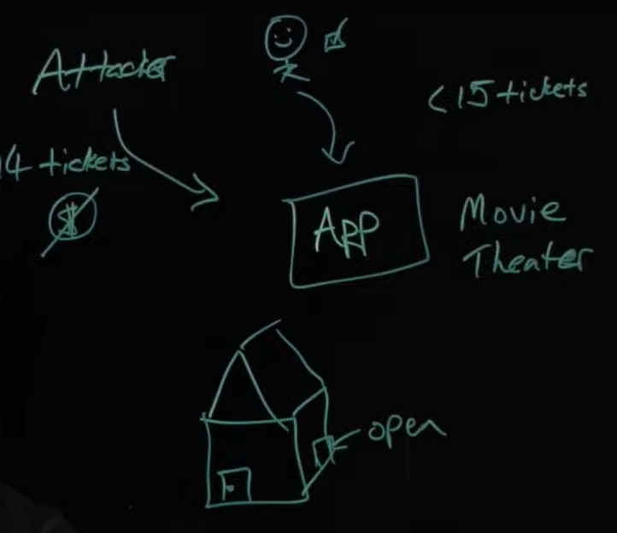

**5. Security Misconfiguration:**

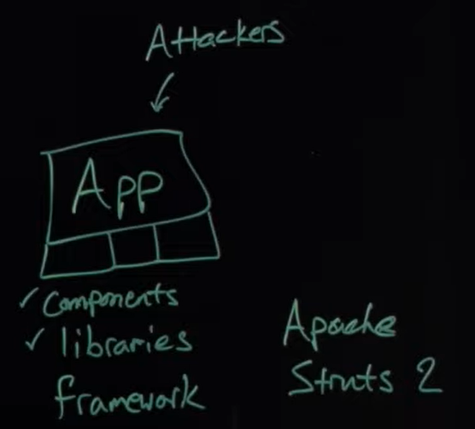

**6.Authentication and Identification:**

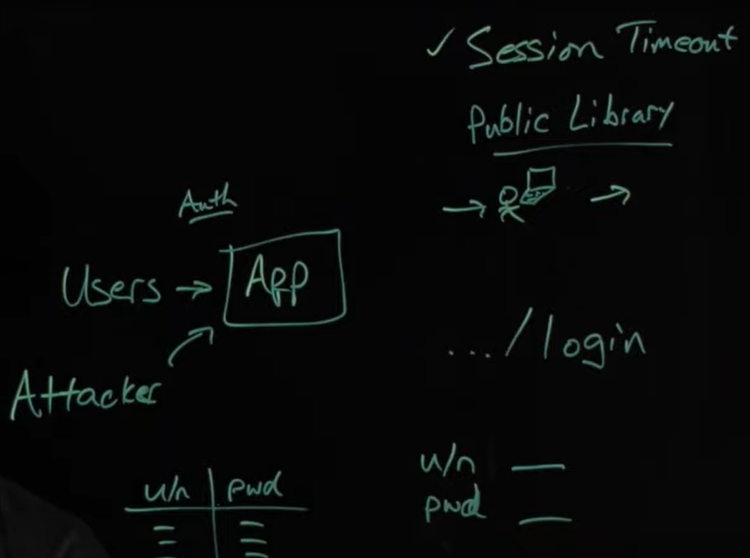

**7.Software and Data Integrity:**

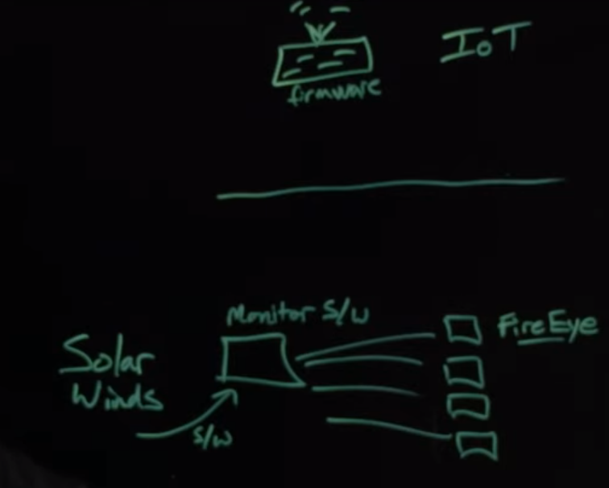

**9. Security Logging and Monitoring:**

**10.Serveer Side Request Forgery.**